DAILY ONLINE ACTIVITIES SUMMARY
Date: |  | 29/05/2020
Name of the Faculty |  | Ankitha Shetty
No. of Students Allotted for monitoring |  |  |  |  | 16
Progress |  |  |  |  | Good
Whether collected report from all the allotted students |  |  |  |  | 12 submitted
Online Test Summary
Subject | Operation Research
Semester | 6 |  |  | Duration |  | 45
No. of students Taken |  |  | 107 | Passing % |  | 98
Certification Course Summary
Course |  | 1)The Future of Artificial Intelligence by ICT Academy  2) Networks & Security
Certificate Provider |  |  |  |  | Duration
Coding Challenges
Problem Statement: Program to solve a system of linear congruence by applying the Chinese Remainder Theorem
Status: 38 students attempted
Uploaded the report in Github |  |  |  |  | Yes
If yes Repository name |  |  |  |  | https://github.com/ankishetty91/ankitha-daily-report
Uploaded the report in slack |  |  |  |  | Yes

Certification Course Summary
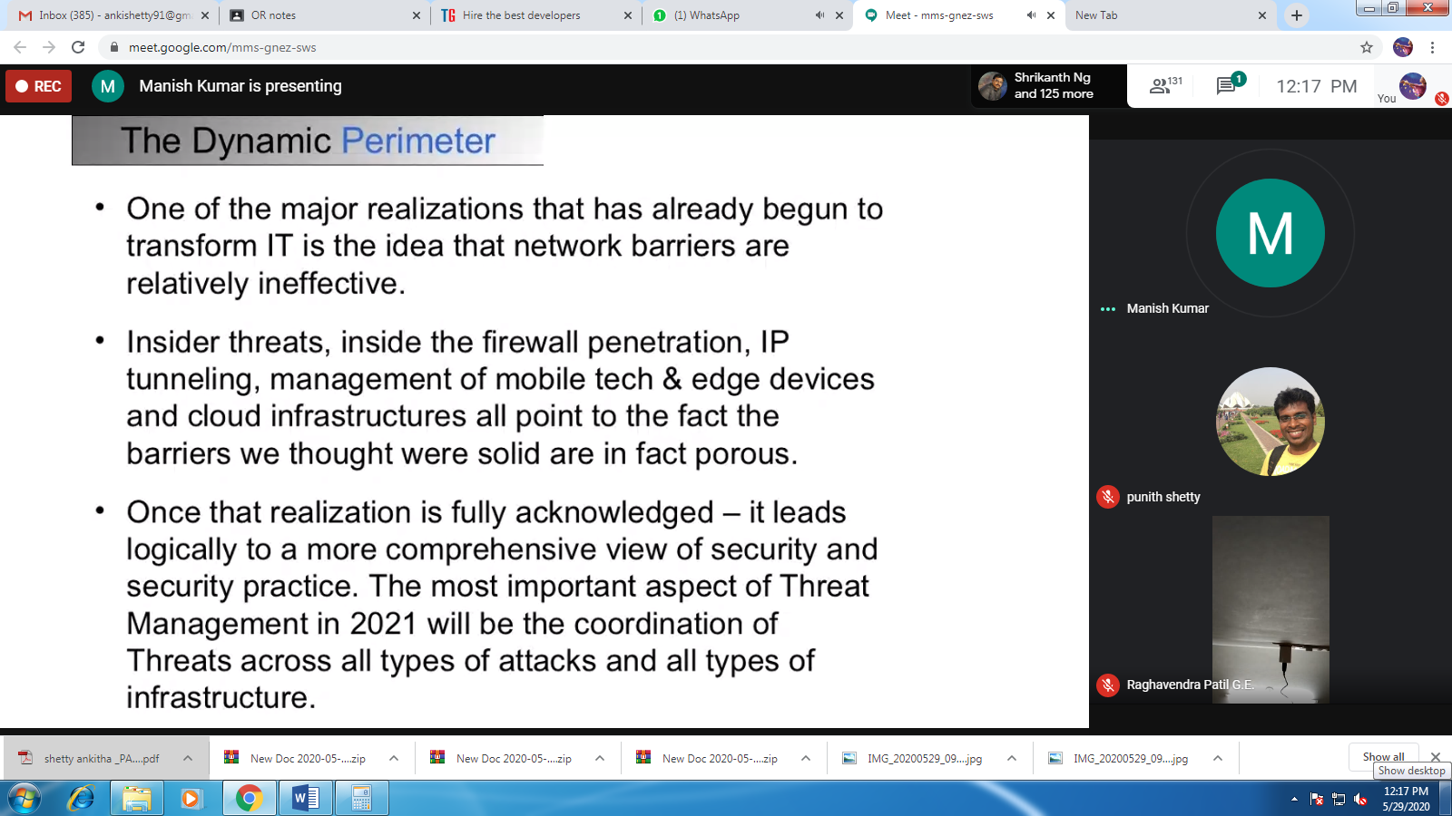
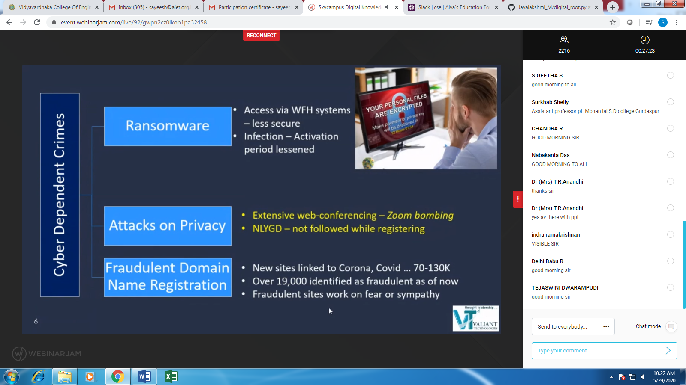
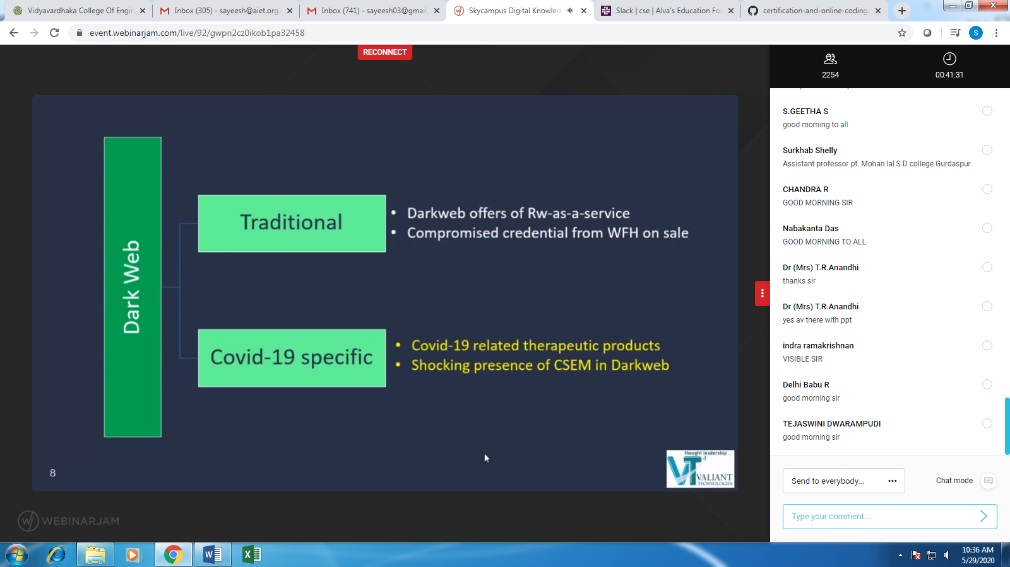

Online Test Summary
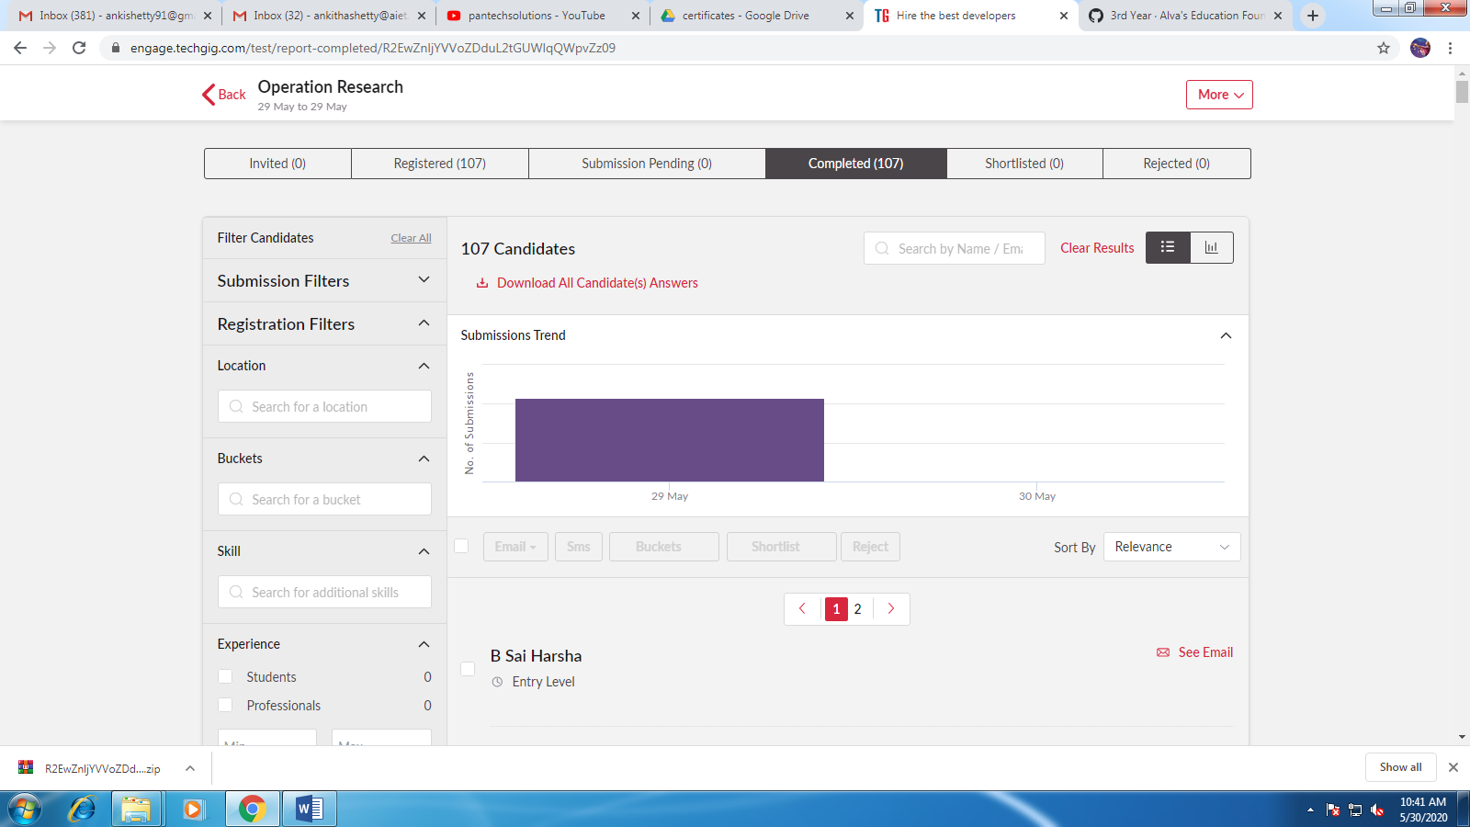
Students Report:

